* Download and install multi branch pipeline plugin and create a multi branch pipeline job
* Inside that, just add GitHub repo details as below

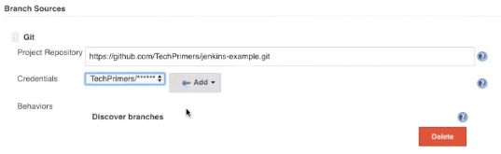

* Once we save it, it automatically fetches the data from GitHub about the branches and all
* After this, the job gets created. If we go inside, we can see the branches in it as below

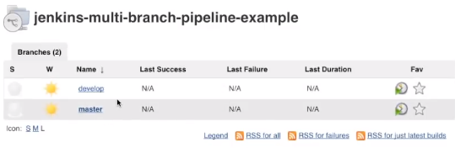

* If we create any new branch and push it to the github, it automatically scans and add it to the job

